# **MULTI-PLATINUM AWARD-WINNING ARTIST JORDAN DAVIS ANNOUNCES 2025 AIN’T ENOUGH ROAD TOUR SATURDAY, SEPTEMBER 27 | CHAIFETZ ARENA**

**Davis’ New Single, “Bar None,” Follows His 8th Career No. 1, “I Ain’t Sayin’” And Marks Next Single Off Of His Highly-Anticipated Upcoming Album**

**Ain’t Enough Road Tour Tickets Available Starting Wednesday, April 2 with Presales**

**General Onsale Begins Friday, April 4 at 10am Local at** [**JordanDavisOfficial.com**](https://www.jordandavisofficial.com/tour/)

**“This man never disappoints.” -*Music Row***

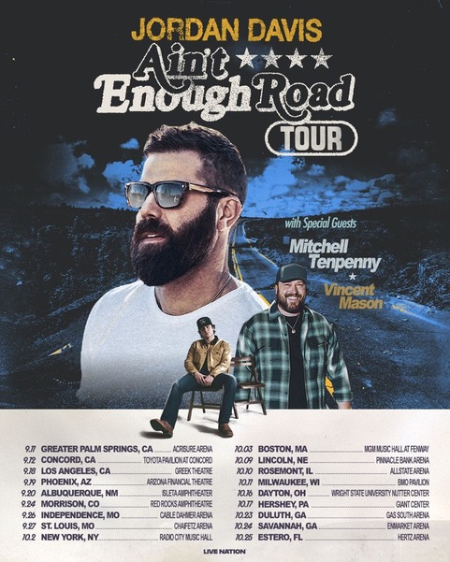

For approved artist images and hi-res tour art, please download [HERE](https://lne.box.com/s/ylrytqi3fux5sa5l9a3m1fhlko4g36k3)

Nashville, TN - March 31, 2025 - Award-winning, Multi-Platinum singer-songwriter, Jordan Davis today announced his 2025 **Ain’t Enough Road Tour** across the U.S. Produced by Live Nation, the nationwide tour kicks off Thursday, September 11 in Greater Palm Springs, CA at Acrisure Arena, with additional stops in Los Angeles, New York, Phoenix, St. Louis, Rosemont, Savannah and more before wrapping up on Saturday, October 25 in Estero, FL at Hertz Arena. **Mitchell Tenpenny** and **Vincent Mason** will join Davis on all upcoming tour stops.

Tickets will be available starting Wednesday, April 2 with various presales. The general on-sale will begin Friday, April 4 at 10am local time at [JordanDavisOfficial.com](https://www.jordandavisofficial.com/tour/).

Davis announced the tour in a video featuring special surprise cameos by sports legends Peyton Manning and Jim Nantz and his fellow tour mates. The video is a comically epic take on just what type of tour the CMA and ACM award-winning star should be doing. Watch [HERE](https://m.youtube.com/watch?v=JK9BDCcu2EI).

In addition to today’s tour announcement, Davis recently released his new single, “Bar None,” off of his highly anticipated next album expected this year. Released to rave reviews, *Music Row* noted “This man never disappoints.” Listen to “Bar None” [here](https://urldefense.com/v3/__https:/jordandavis.lnk.to/BarNone__;!!CxwJSw!P1V9NJ8u9WZ6ayFhCWdmGObKVIPLbRpfW5VlMANu6i1FKFx9jBmrEzAd0aLWbgUwzI4kvB8kf96hEN7jzIrPDpN510NUuQ$). Produced by Paul DiGiovanni and written by Hunter Phelps, Lydia Vaughn, and Ben Johns, “Bar None” follows his latest #1 single, “I Ain’t Sayin,’” which earned 8 weeks at #1 in the UK and marked both Davis’ first single off of the new album and his #1 off his new album both in the US and UK. The new album is the follow up to Jordan's Platinum-selling breakthrough album Bluebird Days, which produced four consecutive #1 singles (“What My World Spins Around,” “Tucson Too Late,” “Buy Dirt” and “Next Thing You Know”) and two “Song of the Year” winning song titles “Next Thing You Know” (ACM) and “Buy Dirt” (CMA and NSAI) off of one album - the first artist in history to ever do that. The single release also comes on the heels of his latest album, *Bluebird Days*, officially going Platinum, joining his previously certified Platinum-selling debut album, *Home State*.

Davis joined CBS Mornings on Monday, 3/31 to discuss the new single and tour and will also make a stop this week on Watch What Happens Live on Bravo with host Andy Cohen on 4/3.

**JORDAN DAVIS: AIN’T ENOUGH ROAD TOUR:**

Thu Sep 11 – Greater Palm Springs, CA – Acrisure Arena

Fri Sep 12 – Concord, CA – Toyota Pavilion at Concord

Thu Sep 18 – Los Angeles, CA – Greek Theatre

Fri Sep 19 – Phoenix, AZ – Arizona Financial Theatre

Sat Sep 20 – Albuquerque, NM – Isleta Amphitheater

Wed Sep 24 – Morrison, CO - Red Rocks Amphitheatre^

Fri Sep 26 – Independence, MO – Cable Dahmer Arena

Sat Sep 27 – St. Louis, MO – Chaifetz Arena

Thu Oct 02 – New York, NY – Radio City Music Hall

Fri Oct 03 – Boston, MA – MGM Music Hall at Fenway

Thu Oct 09 – Lincoln, NE – Pinnacle Bank Arena

Fri Oct 10 – Rosemont, IL – Allstate Arena

Sat Oct 11 – Milwaukee, WI – BMO Pavilion

Thu Oct 16 – Dayton, OH – Wright State University Nutter Center

Fri Oct 17 – Hershey, PA – Giant Center

Thu Oct 23 – Duluth, GA – Gas South Arena

Fri Oct 24 – Savannah, GA – Enmarket Arena

Sat Oct 25 – Estero, FL – Hertz Arena*

*On sale April 18 at 10am local time

^Non-Live Nation date

About Jordan Davis:

Award-winning, multi-platinum singer/songwriter Jordan Davis’ highly-anticipated second full-length album, *Bluebird Days*, produced four consecutive #1’s and three “song of the year” award-winning titles including the 5X Platinum-selling hit “Buy Dirt,” (CMA Awards 2022, NSAI Awards 2023) and 3X Platinum-selling “Next Thing You Know” (ACM Awards 2024). All penned by Davis, the Louisiana-born and raised star also released the chart-topping hit singles "What My World Spins Around" and "Tucson Too Late,” in addition to “Next Thing You Know” and “Buy Dirt,” earning numerous award nominations, including CMA, ACM, CMT, American Music Award, Billboard Music Award and iHeart Award nods as well as his second Platinum-Certified album, *Bluebird Days*. Davis previously notched three consecutive No. 1 hits-totaling eight #1s on Country radio - off of his Platinum-Certified debut album *Home State* including the 3x Platinum "Singles You Up," and 2x Platinum-selling songs "Take It From Me" and "Slow Dance In A Parking Lot” along with his most recent No.1 single “I Ain’t Sayin’.” In 2019, Davis was awarded Best New Country Artist at the iHeartRadio Music Awards, in addition to being a 2X nominee for ACM New Male Artist of the Year, he was named Billboard's Top New Country Artist of 2018. He’s appeared on Good Morning America, TODAY, Late Night with Seth Meyers, The Tonight Show Starring Jimmy Fallon, Jimmy Kimmel Live, The Kelly Clarkson Show, College GameDay, and more. Starting 2025 off internationally, Davis served as direct support for Luke Combs’ stadium tour in New Zealand and Australia. Additionally, Davis was direct support for Luke on his 2024 Growin’ Up and Getting Old Tour and followed with his string of U.S. and international shows headlining his DAMN GOOD TIME TOUR in the fall of 2024. Davis is currently at work on his new album and released “I Ain’t Sayin’,” “Know You Like That,” and recent release “Bar None.” For more information, visit [JordanDavisOfficial.com](https://urldefense.com/v3/__http:/jordandavisofficial.com/__;!!CxwJSw!P1V9NJ8u9WZ6ayFhCWdmGObKVIPLbRpfW5VlMANu6i1FKFx9jBmrEzAd0aLWbgUwzI4kvB8kf96hEN7jzIrPDpMO_VmiWg$) ([http://jordandavisofficial.com/](https://urldefense.com/v3/__http:/jordandavisofficial.com/__;!!CxwJSw!P1V9NJ8u9WZ6ayFhCWdmGObKVIPLbRpfW5VlMANu6i1FKFx9jBmrEzAd0aLWbgUwzI4kvB8kf96hEN7jzIrPDpMO_VmiWg$)).

**MEDIA CONTACTS:**

**For Jordan Davis:**

Jennifer Vessio | [jennifer.g.vessio@gmail.com](mailto:jennifer.g.vessio@gmail.com)

**Live Nation Concerts**

Monique Sowinski | [moniquesowinski@livenation.com](mailto:moniquesowinski@livenation.com)

Maya Sarin | [mayasarin@livenation.com](mailto:mayasarin@livenation.com)

**Universal Music Nashville:**

Leigh Malleus | [leigh.malleus@umusic.com](mailto:leigh.malleus@umusic.com)

To apply for media credentials for show coverage:

[livenation.com/pressrequests](https://lne.secure.force.com/mktEventSearch?category=PR)